**Assingment-1**

**Python programming**

Assingment date:19 september 2002

Student name :K.dhanalakshmi

Student reg.no :921819104008

Maximum marks:2marks

1)Write a program which can compute the factorial of a given numbers. The results should be printed in a comma-separated sequence on a single line.

|  |
| --- |
| Deffactorial(n): |
|  | value = 1 |
|  | for i in range(1, n+1): |
|  | value = value * i |
|  | return value |
|  |  |
|  | number = int(input("Type a number: ")) |
|  | print(factorial(number)) |

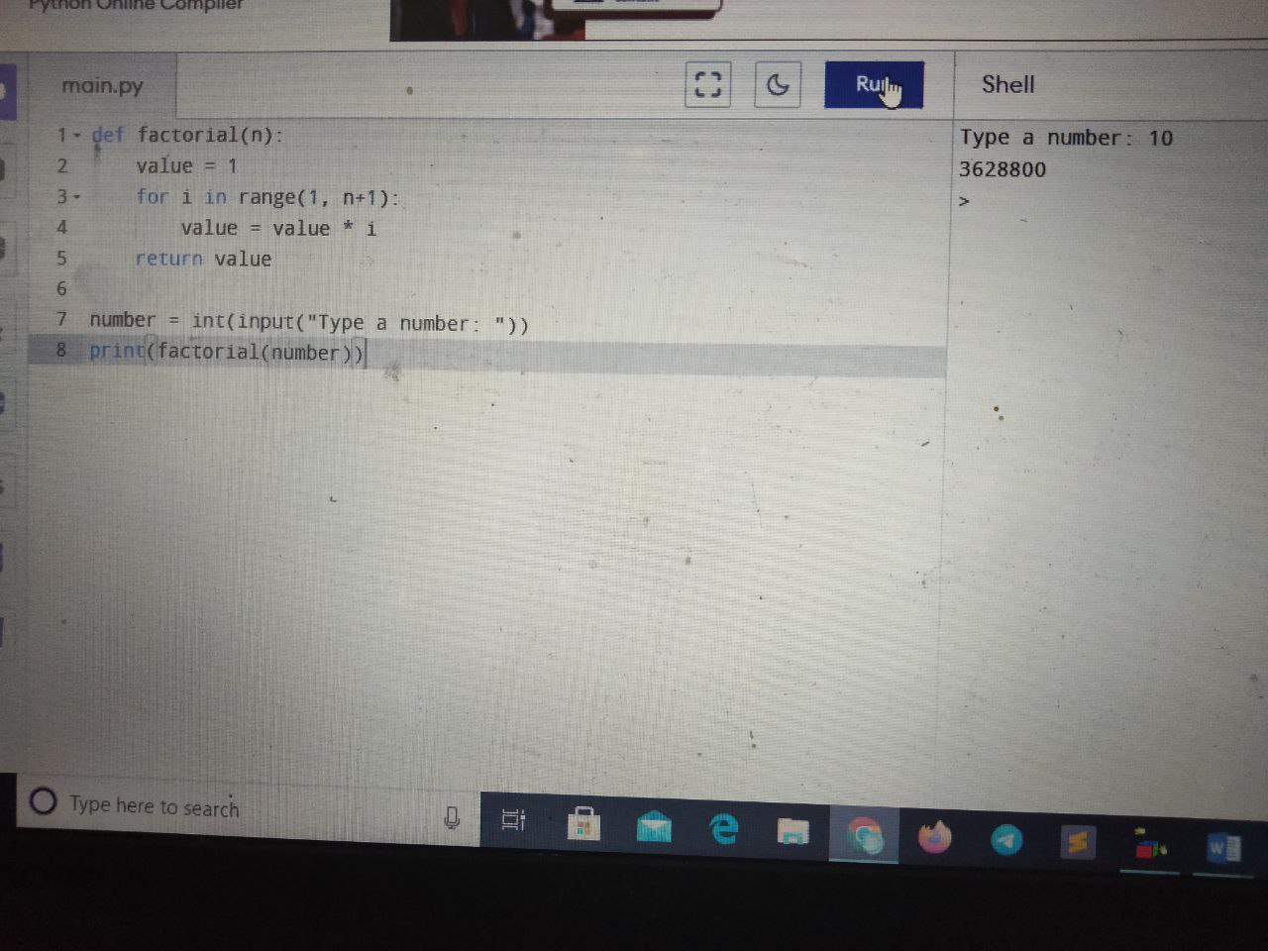

2) Write a Python program that accepts a comma separated sequence of words as input and prints the unique words in sorted form (alphanumerically).

items = input("Input comma separated sequence of words")

words = [word for word in items.split(",")]

print(",".join(sorted(list(set(words)))))

